**Variables**

Variables are containers for storing data values.

In Java, there are different **types** of variables, for example:

* String - stores text, such as "Hello". String values are surrounded by double quotes
* int - stores integers (whole numbers), without decimals, such as 123 or -123
* float - stores floating point numbers, with decimals, such as 19.99 or -19.99
* char - stores single characters, such as 'a' or 'B'. Char values are surrounded by single quotes
* boolean - stores values with two states: true or false

int myNum;

myNum = 15;

System.out.println(myNum);

int myNum = 15;

myNum = 20; // myNum is now 20

System.out.println(myNum);

final int myNum = 15;

myNum = 20; // will generate an error: cannot assign a value to a final variable

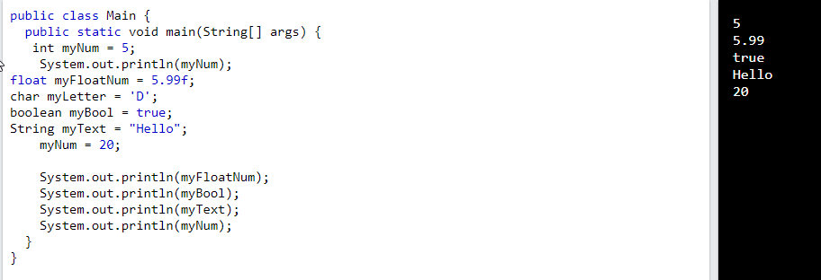

String firstName = "John ";

String lastName = "Doe";

String fullName = firstName + lastName;

System.out.println(fullName);

**String Concatenation**

String firstName = "John";

String lastName = "Doe";

System.out.println(firstName + " " + lastName);

## Adding Numbers and Strings

int x = 10;

int y = 20;

int z = x + y; // z will be 30 (an integer/number)

String x = "10";

String y = "20";

String z = x + y; // z will be 1020 (a String)

String x = "10";

int y = 20;

String z = x + y; // z will be 1020 (a String)

int x = 5;

int y = 6;

System.out.println(x + y); // Print the value of x + y

int x = 5;

int y = 6;

int z = 50;

System.out.println(x + y + z);

int x = 5, y = 6, z = 50;

System.out.println(x + y + z);

int x, y, z;

x = y = z = 50;

System.out.println(x + y + z);

Variables:

Variables are used to store data within a program. In Java, variables can be of different types, such as int, double, String, etc.

**// Example of variables**

int age = 25;

double price = 19.99;

String name = "John";

## Strings - Special Characters

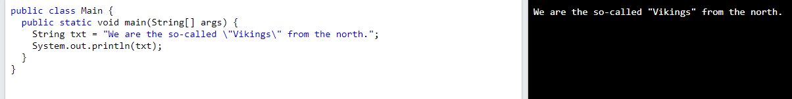

**Operators**

Java divides the operators into the following groups:

* Arithmetic operators
* Assignment operators
* Comparison operators
* Logical operators
* Bitwise operators

1. **simple Java program for beginners.**

**This program takes input from the user, performs a calculation, and then prints the result.**

import java.util.Scanner;

public class SimpleCalculator {

public static void main(String[] args) {

// Creating a Scanner object to take user input

Scanner scanner = new Scanner(System.in);

// Taking input for the first number

System.out.print("Enter the first number: ");

double num1 = scanner.nextDouble();

// Taking input for the second number

System.out.print("Enter the second number: ");

double num2 = scanner.nextDouble();

// Performing addition, subtraction, multiplication, and division

double sum = num1 + num2;

double difference = num1 - num2;

double product = num1 * num2;

double quotient = num1 / num2;

// Printing the results

System.out.println("Sum: " + sum);

System.out.println("Difference: " + difference);

System.out.println("Product: " + product);

System.out.println("Quotient: " + quotient);

// Closing the Scanner to prevent resource leak

scanner.close();

}

}

Explanation:

* The program starts by importing the Scanner class from the java.util package to take input from the user.
* It defines a class named SimpleCalculator.
* The main method is the entry point of the program.
* The program creates a Scanner object to read input from the user.
* It prompts the user to enter two numbers, reads the input, and performs addition, subtraction, multiplication, and division.
* The results are then printed to the console.
* Finally, the Scanner is closed to prevent a resource leak.

Compile and run this program, and it will ask the user for two numbers, perform basic calculations, and display the results.

**Conditional Statements**

Here are examples of different conditional statements in Java: **if, if-else, if-else if-else, and switch-case.**

**1. If Statement:**

public class IfExample {

public static void main(String[] args) {

int number = 10;

// Simple if statement

if (number > 0) {

System.out.println("The number is positive.");

}

}

}

**2. If-Else Statement:**

public class IfElseExample {

public static void main(String[] args) {

int number = -5;

// If-else statement

if (number > 0) {

System.out.println("The number is positive.");

} else {

System.out.println("The number is not positive.");

}

}

}

**3. If-Else If-Else Statement:**

public class IfElseIfExample {

public static void main(String[] args) {

int number = 0;

// If-else if-else statement

if (number > 0) {

System.out.println("The number is positive.");

} else if (number < 0) {

System.out.println("The number is negative.");

} else {

System.out.println("The number is zero.");

}

}

}

**4. Switch-Case Statement:**

public class SwitchCaseExample {

public static void main(String[] args) {

int dayOfWeek = 3;

// Switch-case statement

switch (dayOfWeek) {

case 1:

System.out.println("Monday");

break;

case 2:

System.out.println("Tuesday");

break;

case 3:

System.out.println("Wednesday");

break;

case 4:

System.out.println("Thursday");

break;

case 5:

System.out.println("Friday");

break;

default:

System.out.println("Weekend");

}

}

}

These examples demonstrate the use of different conditional statements in Java. You can modify the values and conditions based on your needs to understand how these statements work.

1. **LOOP STATEMENTS**

Here are examples of three types of loop statements in Java: **for, while, and do-while**. Each loop will be demonstrated with a simple and different example:

**1. for Loop:**

public class ForLoopExample {

public static void main(String[] args) {

// Example: Print numbers from 1 to 5 using a for loop

for (int i = 1; i <= 5; i++) {

System.out.println(i);

}

}

}

**2. while Loop:**

public class WhileLoopExample {

public static void main(String[] args) {

// Example: Print even numbers from 2 to 10 using a while loop

int i = 2;

while (i <= 10) {

System.out.println(i);

i += 2;

}

}

}

**3. do-while Loop:**

public class DoWhileLoopExample {

public static void main(String[] args) {

// Example: Print numbers from 1 to 5 using a do-while loop

int i = 1;

do {

System.out.println(i);

i++;

} while (i <= 5);

}

}

**Explanation:**

**for Loop Example:**

The for loop has three parts: **initialization (int i = 1), condition (i <= 5), and update (i++).**

It prints numbers from 1 to 5.

**while Loop Example:**

The while loop has only **a condition (i <= 10).**

It prints even numbers from 2 to 10.

**do-while Loop Example:**

The do-while loop guarantees that the loop body executes at least once before checking the condition.

It prints numbers from 1 to 5.

Compile and run each program to see the output. These examples cover the basic usage of for, while, and do-while loops in Java.